DART TOURNAMENT

ELECTRONIC DARTBOARD

User Guide
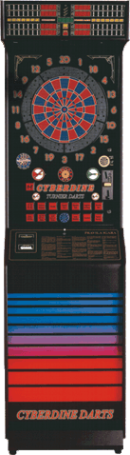
Congratiolations on choosing an electronic dartboard CYBERDINE Dart Tournament, official unit on EDU (European Dart Union) tournaments.
We are sure that this unit will reward You with many moments of enjoyment which You are going to spend with your friends at Your favourite gathering place. We from CYBERDINE have invested maximum amount of effort in order to provide a unit in which design, quality, choice of games, opportunities and enjoyment are developed especially in order to provide a full satisfaction to the players / contestants. We wish you a lot of luck and free time in order to have a lot of enjoyment with our units. This user guide consists of a lot of important information on safety and the use of this unit so we would like to study them well.
Copyright © CYBERDINE d.o.o. O. Ivekovica 1, HR-10000 Zagreb
Tel: +385 (0) 1 2004 920, Tel./Fax: +385 (0) 1 2004 922
Internet: http://www.cyberdine.hr, E-mail: sales@cyberdine.hr

Complete contents of the User Guidelines are an exclusive property of CYBERDINE d.o.o. in reference to the Law which relate to copyright and the Laws which relate to intellectual property as well as patent rights. No part of these User Guidelines can be used, reproduced, multiplied in any way, published in any media format, briefly given to a third party without our written authority. Detaining rights in reference to the Law Acts.
Technical descriptions contained in these User Guidelines, in may instances rigorously controlled, are not obliged by CYBERDINE d.o.o. contain rights, containing primary unit characteristics, that would in any moment, withour priror announcment, perform any changes which are considered to be required to improve the unit.

WARRANTY

CYBERDINE secures warranty in all countries in which they are obliged, ensuring repair at our own expenses relating to all abnormalities, even hidden and even in the case, the that the User is in the state to demonstrate a malfunction or a factory fault of the unit.
CYBERDINE guarantees that will function properly complying to the User Guidelines within the period of one (1) year from the day of purchase of the unit providing spare parts and service personnel free of charge, in case that the Warranty Certificate has been clearly filled in at the time of purchase, verified by the seal and the date from the authorised sales representative.
Warranty is not valid for any unit which is purchased in another country in which there are different safety standards and regulations from the one that are used, from which a purchaser refuses to provide necessary modifications at his own expense to bring the unit to the appropriate state of conformity and to the appropriate standards.
Warranty doesn't cover:
- Normal wear & tear caused by the use of the unit,
- Disassembly which is not expected and followed by the User Guide guidelines,
- Connection to an inappropriate voltage setting which do not comply with the settings located in the User's Guide.,
- Physically abusing and / or dropping the unit,
- Usage of the equipment in a way which is not described in the User Guidelines and to the vandal acts towards the unit,
- CYBERDINE is not responsible for the material expenses or accidents which are a result after an installation of the unit on the contrary to the appropriate safety measures related to the standards required in that country in which the unit will be used. In neither case does this Warranty provide rights to the compensation,
- Travelling expenses, lease and transport caused for unit resulting to become faulty,
- Additional damage caused by the third party.
The unit is conformant to the standards which relate to the limitations of the radio interference.

IMPORTANT WARNING!

ATTENTION: Please read carefully the user instructions prior to commence the assembly and use of the unit.

Please do not transport the unit in the fully assembled state!

Connection to the electricity: Voltage: 90 V – 260 V,

Maximum power consumption: 100 W.

When the unit is assembled and connected to an electric wire, switch the master switch 1 (ON).
CAUTION: All units CYBERDINE TOURNAMENT DARTS are manufactured with the grounding circuit so use suitable connections with protective grounding (European connector).


CAUTION:
1.Do not try to open the unit by force. The unit does not contain any parts or components to which the user will be able to repair. If there is a need for a repair of the unit, go to the nearest authorized service center or directly to our office.
2.Various openings which are located at the upper body of the unit, on the rear side and on the base are used for airing and ventilation of the interior as well as for cooling purposes. To ensure proper functioning of your unit, and to prevent overheating these exits must be freely cleared from any obstructions at all times.
3.No metal part or similar foreign material must not be able to access to the internal unit through these vents. Reason being is that it may come to contact with the components under voltage and produce a short circuit or even a fire.
4.
The unit must not be installed or located close to the heat source.
5.It is necessary in any case to avoid spillage of any form of liquid on the unit ( wine, beer, coffee…). In case if it does happen, it is imperative to check the functionality of the unit by the experienced personnel. (resort to the closest service department or our office).
6.It is important to store or keep the unit in the rooms without excessive dampness or in the open environment.

Within the unit there are no voltage potential which could endanger life, all of the circuits use a voltage potential of 5 Volts or 12 Volts.

CONTENTS

Str
- PRIMARY REMARKS ON ELEKTRONIC DART BOARD 6
- SYSTEM INSTALLATION AND SETTINGS _____7
- IN BRIEF (QUICK START) 9
- SYSTEM DESCRIPTION (PRIMARY FUNCTIONS 10
  - SYSTEM SCHEMATICS 10
  - TARGET 10
  - BUTTONS 12
    - Model without options QUATTRO 14
  - DISPLAY 15
  - COIN SLOT 15
- MICROSWITCHES (DIP SWITCH) 16
  - TEST MENU 17
    - Test target 18
    - Test light 18
    - Test button 19
    - Test infra 19
    - Test tup 21
    - Test credit 22
  - STATISTICS 22
  - ATTRACT 23
  - MAIN BOOKKEEPING _____23
  - SECONDARY BOOKKEEPING 23
  - TOURNAMENT MODE 24
  - INITIALISATION 24
  - PAREMETER SETUP __________24
    - Price Adjust 25
    - Happy price 26
    - Round Adjust 27
    - Happy Round 27
    - Setup Clock 28
    - Setup Happy Hour 28
    - Bonus Percent 28
    - Bonus Credit 29
    - Time limit 29
    - Counter Pulses 30
    - Switch Credit 30
    - Time - Credits 30
    - Publicity 31
    - Lottery 31
    - Option Remember 31
    - Demo Sound 32
    - Quattro Mode ON 32
    - Return Dart 32
    - Bull Value 33
    - Play off 33
    - Main Lamp 34
    - Back Light 34
    - Infra sensor 34
    - Acceptor 35
  - TONE 35
- GAME RULES _____36
- GAME COMBINATIONS 40
- SPARE PARTS 43
- PROBLEMS AND SOLUTIONS (TROUBLESHOOTING) 45
- CONNECTORS 47
- BILL ACCEPTOR 50

1. GETTING ACQUAINTED WITH THE CYBERDINE TOURNAMENT DART BOARD

CYBERDINE TOURNAMENT DART BOARD is an electronic, entertaining, sports Dart Board with electronic addition of points and arrows which enables to play traditional games (301, Cricket...), and the unit has all the new modern GAMES, as well as the OPTIONS for these GAMES. The individual Dart Board is unharmful attractive and overall an entertaining sports game dispersed throughout the whole world. Dart Board is one of the oldest entertaining sports disciplines and games. The first traditional TOURNAMENT was dated even back from 1927. and was called “New of the World”, until during the TOURNAMENT held in London 1948., over 300.000 players have participated in the game. Epoch of electronic dart boards has commenced in the mid 80’s, and the popularity of electronic dartboards is continually growing and has greatly superseded the popularity of the traditional dart boards.
The unit is constructed in such a way to ease and simplify the game to the player and leads the player through a game with light and sound effects. The main characteristics which the CYBERDINE TOURNAMENT DART BOARD have, and ease the exploitation are:
- Automatic change of the player
- Automatic subtraction of missed arrows
- Light signaling
- Sound signaling
- Electronic and a mechanical counter with simplified readings
- Single (both centers 50) and double center (25-50)
- Advertisement in the Demo mode
- Enabling the credits with the key or different types of tokens, possibility of remotely enabling the credits.
- Prize winning game
- Standing and the wall version of the unit
- 8 players, 8 Crickets
- Simple test parameter settings of the GAMES, and the pricing of the games
- FAIR PLAY OPTIONS - EQUAL (same number of circuits for all), PLAY OFF ( keep the player in high spirits with the same amount of points) and END (proceeding the GAMES till the end)
- Simplified setting of standard values
- Attractive Demo mode
- Attractive melody
- QUATTRO option (quadruple segments)

CYBERDINE TOURNAMENT DART BOARD units are a result of many years of experience.

2. INSTALLATION AND THE SETUP OF THE UNIT

There is a maximum protection of the unit during transport, it has carefully being worked out and tested during the practice during many years... The unit is protected by its own method of assembling (Diagram.1), strengthening the metal plates which are used for the transportation purposes and during the disassembly is removed, then covered with a fivefold thickness carton box for further protection.

Diagram 1. – Device in the closed state

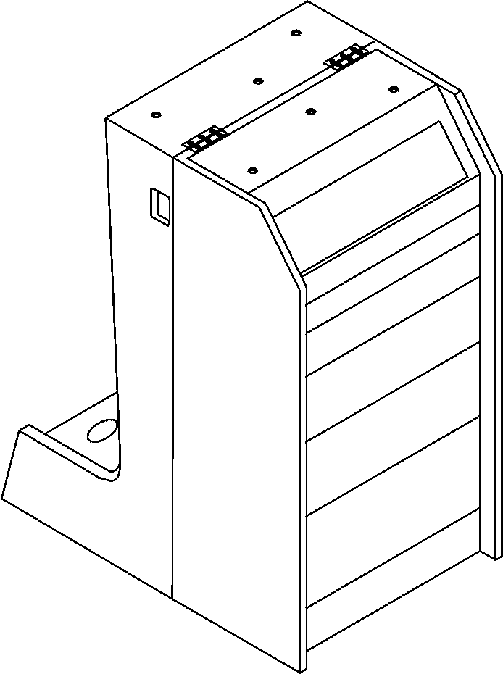
Upper part of the Dart Board aparata
Lower part of the Dart Board
Screw holes
Hinges
Operation during the assembly of the unit:

- Remove the key from the cash box draw which is located in the upper part of the pedestal.
- On the lower draw are located torque screws, other keys, arrows, wire cable, tips and start lines.
- Cover the upper part on the pedestal, tightening it with the torque screws which are located in the cash box.
- In this way the unit is completely assembled.

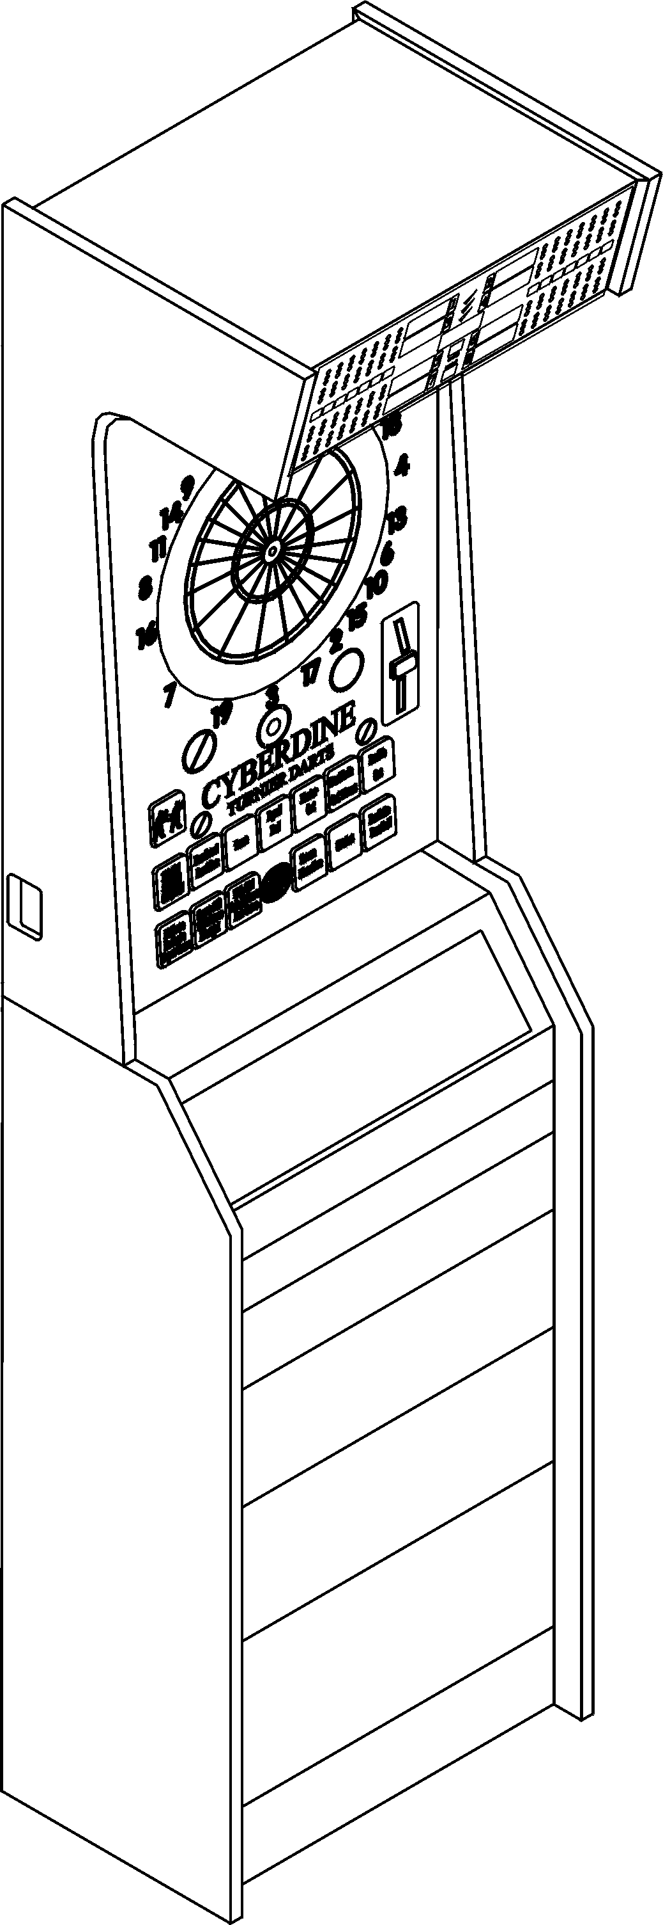
Diagram 2. – Unit ready for use
Display
Target
Slot Unit
Buttons
Door for the “cash box” space
Switch
Power Conector plug

Properly set unit
Target Centre
Start line
The Unit has to be located in a place where the players will not be interfered from the other people and the people who are walking through the game area. Start line has to be set from the Start line which has to be placed from the face front of the target at a distance of 244cm (in majority of the countries), and in some countries 237cm, and in United States 8 feet. Therefore check the rules of distance in your country.

3. BRIEFLY (QUICK START)

This paragraph is intended to the personnel who have an experience with the electronic Dart Boards and is put together as a small reminder for the operations which have to be done to immediately start with the games.
Operating procedures are as follows:

1. Remove the carton box which acts as packaging material,
2. Connect both the upper and lower section of the unit using the screws which are located in the cash box compartment ( for more details See paragraph 2.),
3. Connect the unit to a powerpoint via the cable which is located in the cash box compartment,
4. Microswitch number. 7 has to be switched on ON position, then turn on the unit (for more detailsa See paragraph 5.) – so are all parameters set to the factory settings (prices, length of the games, …),
5. Microswitch number / has to be turned on OFF position then closing the front door.
6. Dart Board is ready for use,
7. Now it is possible to choose the desired game,
8. The game can be started.

For more information which are related to assembly, connection, parameter setup and other functions, we urge You carefully read the whole contents in the User's Guide.

4. UNIT DESCRIPTION (PRIMARY FUNCTIONS)
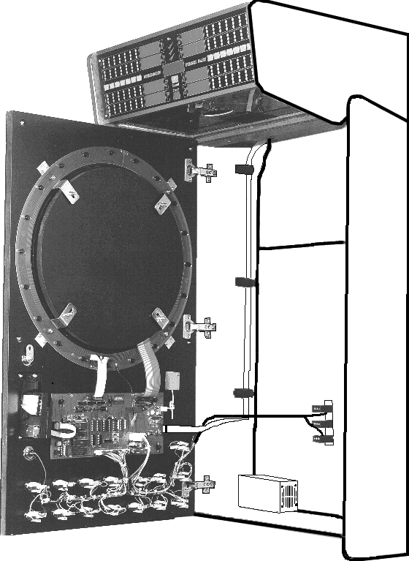
4.1 UNIT SCHEMATICS
Woden support for the target
Winged nuts holding the target
Sensor field connector
Speaker
Halogen Light
Infra sensor
Slot unit
CPU board
Counters
Supply
“Tup” senzor
Slika 3. – Unutrašnjost aparata
On Diagram number 3. we see the internal view of the unit. Maintenance of the unit and cleaning of the target and replacement of any electronic component (CPU, display, peripheral units) is very simple. During the disconnection of the wires it is not possible to change the Connectors relative to the length of the wires and the usage of various types of Connectors.

4.2. TARGET
Diagram 4. - Target

Center (BULLSEYE) inside
BULLSEYE outside
Single segment
Double segment
Triple segment
Quadriplei segment (QUATTRO models only)
Spines
DIASASSEMBLY AND THE MAINTENANCE OF THE TARGET
After a few thousand games broken arrow points could fill in or clogg target segments, resulting the arrows not being able to stick on the dart board. Then is the time to clean the dart board. Points which stick out, have to be removed by a pair of pliers, and the ones that cannot be removed by the pair of pliers, have to be pressed to the inner side of the segment and disassemble the target and extract the pushed points.

Null sector
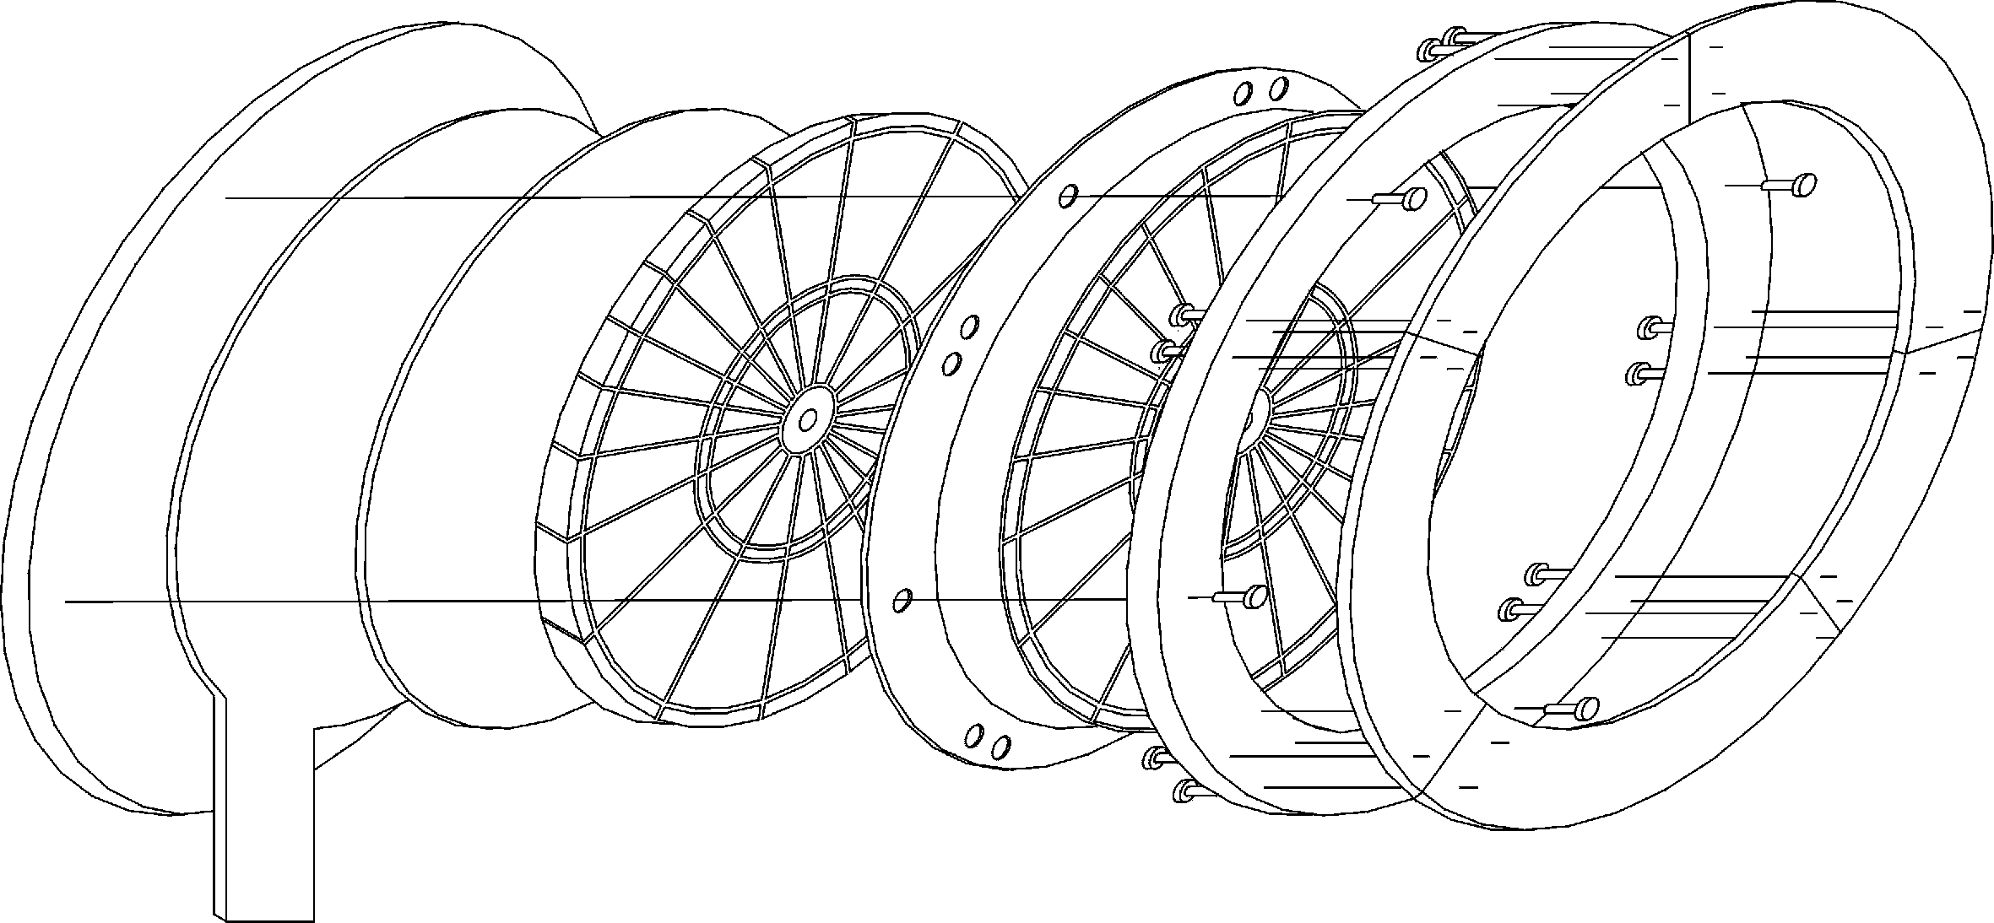
Wood
Sensor field
Rubber
Spine
Wood
Segments
Screws

Target parts (for further information See paragraph 8.)
WARNING: Careless and incautious handling of the target and its parts could cause damage and provoke damage to the dart board or its parts. For a safe disassembly of the target follow the step-by-step operating procedures mentioned below.
Sequence of the operations of disassembling the dart board:
- Turn off the unit, open upper door and disconnect the sensor field connector on the electronics board (Diagram. 3);
- Unwind 4 wing nuts (Diagram. 3) and take out the target from its base;
- Unwind 4 wing nuts from the rear side of the target and remove the wooden base;
- Carefully unwind the two screws from the sensor field and remove the sensor field and protective rubber;
- Remove the broken tips and assemble the target board to the opposite side;
- After every disassembla and assembly it is important to to check the sensor field function duting test, test the target board (See paragraph. 5.1.1.).
All of the parts from the target board are available as the spare parts. For further information see paragraph 8.

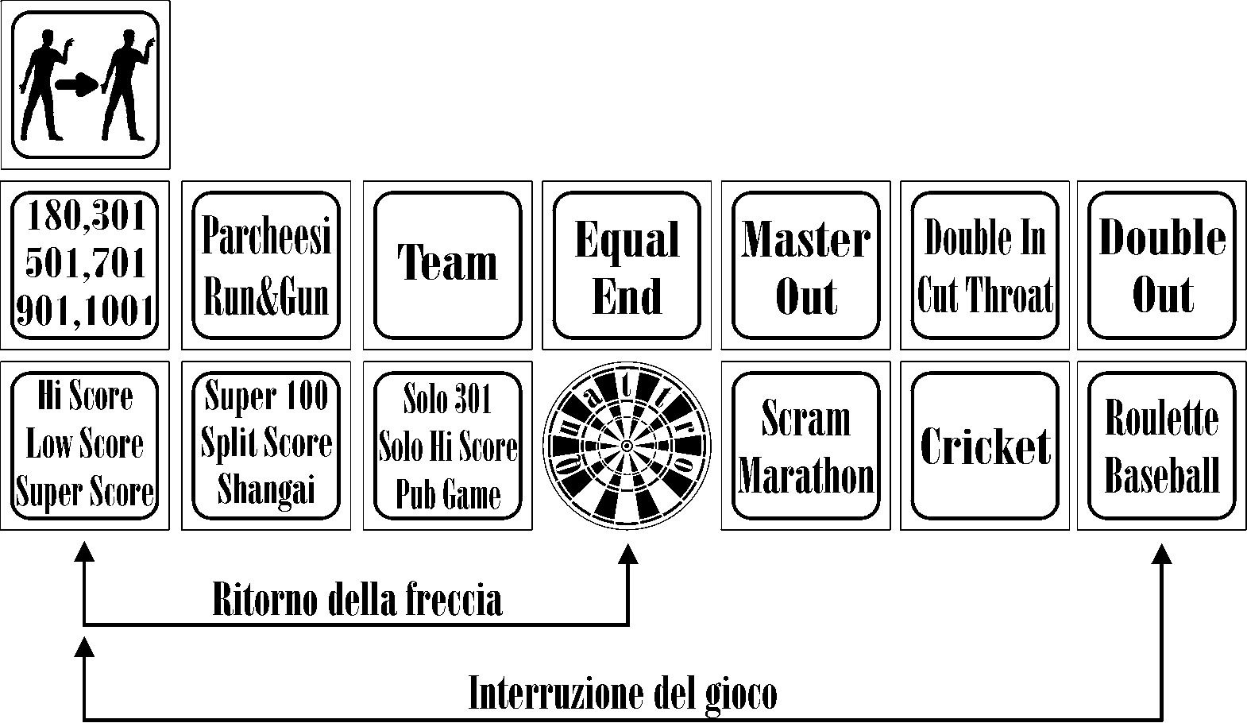
4.3. Buttons
Diagram 5. - Button layout (QUATTRO model option)
PoDoork arrows
InterruptGAMES

On the Diagram number 5, we see the layout of the buttons on the door of the unit. When we turn on the credit, buttons which are used for chosing a game start blinking. On the buttons which have more functions, by pressing on the button the games are changing, eg. For a 501 game we have to press the button 3 times, and on the TEMPORAL display because of the ensurance of our choice of the game being selected GAMES is displayed. When we choose a game, then their OPTIONS blink and we have the chance to choose those options until the game starts, although the button lights stop blinking in the meantime. On CRICKET display the GAMES option is written to display our choice.



Description of each individual button:
    By this button we change the players after each played round and the beginning of the game, we determine the number of players. | Button for a fair play Choice option (see also paragraph 6 and 7 for the game rules and the combinations of the games).
    By this button we choose the traditional GAMES: 180, 301, 501, 701, 1001. | Button for the QUATTRO OPTIONS Choice.
Button for the Choice type of scoring the game (see also paragraph 6 and 7 for the rules of the game and the possible combinations of the games). | Button for the Choice type of ending the game (see also paragraph 6 and 7 for the rules of the game and the possible combinations of the games).
                  Button for the Choice in the games which can be limited by time (see also paragraph 6 and 7 for the rules of the game and the possible combinations of the games). | Button za Choice novih igara osim onih tradicionalnih (see also paragraph 6 and 7 for the rules of the game and the possible combinations of the games).
Button for the Choice of the new games except the traditional ones (see also paragraph 6 and 7 for the rules of the game and the possible combinations of the games). | Button for the Choice type to commence a game called Cut Throat (see also paragraph 6 and 7 for the rules of the gameand the possible combinations of the games).
Button for the Choice OPTIONS team – with the button Players by you select the number of players on each team and the Choice is seen on the “CRICKET” display | Button for the Choice of the new GAMES (see also paragraph 6 and 7 for the rules of the game and the possible combinations of the games).
Button for the Choice for only a single person playing GAMES Pub Game (see also paragraph 6 and 7 for the rules of the game and the possible combinations of the games). | Button for the Choice how to end the game (exiting from GAMES) except in the Roullette game (see also paragraph 6 and 7 for the rules of the game and the possible combinations of the games).
 | Button for the Choice of the new games (see also paragraph 6 and 7 for the rules of the game and the possible combinations of the games).

HOW TO SKIP A ROUND
In case of any reason that the player has to skip his round he has to press the buttonu Players for three seconds and then release it.
ARROW RETURN
Press the buttons at the same time Hi, Low Score, Super Score and QUATTRO. This option enables a return of a single arrow in every round of the game (for any reason being) so that the player has 4 arrows on disposal. In order to enable this function, See paragraph 5.9.7.
STOPPING THE GAMES
In any event it is possible by pressing the buttons at the same time Hi Score, Low Score, Super Score i Roulette, Baseball, you are able to stop or start a new game from the beginning.
4.3.1. Model without QUATTRO OPTIONS

Buttons with the models without the QUATTRO OPTIONS are in reality the same, except that some buttons have different functions or the layout is slightly different.
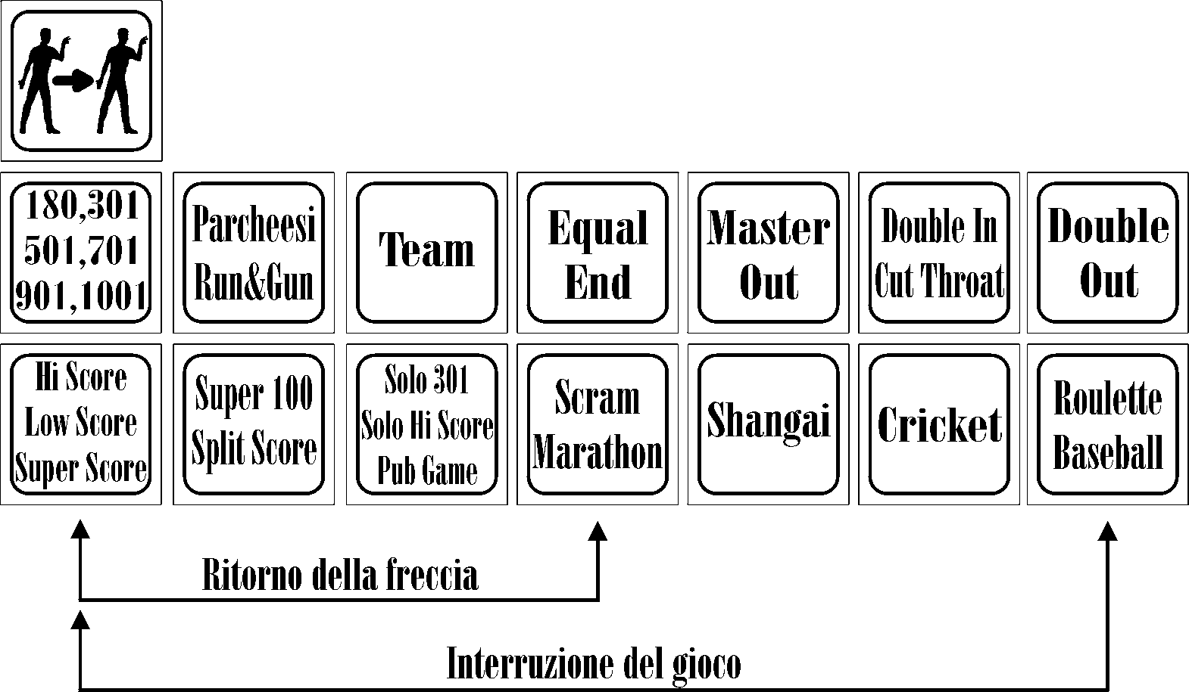
Buttons which differ by their functions or their layout are described in sequence.
PoDoork arrows

Interrupt GAMES

Diagram 6 – Button outlay (model without QUATTRO OPTIONS)


  Button for the Choice options for the traditional GAMES (see also paragraph 6 and 7 for the rules of the game and the possible combinations of the games). | Button for the Choice GAMES Shangai (see also paragraph 6 and 7 for the rules of the game and the possible combinations of the games).

HOW TO SKIP A ROUND
In case of any reason that the player has to skip his round he has to press the buttonu Players for three seconds and then release it.
ARROW RETURN
Press the buttons at the same time Hi, Low Score, Super Score and QUATTRO. This option enables a return of a single arrow in every round of the game (for any reason being) so that the player has 4 arrows on disposal. In order to enable this function See paragraph 5.9.7.

STOPPING THE GAMES
In any event it is possible by pressing the buttons at the same time Hi Score, Low Score, Super Score i Roulette, Baseball, you are able to stop or start a new game from the beginning.

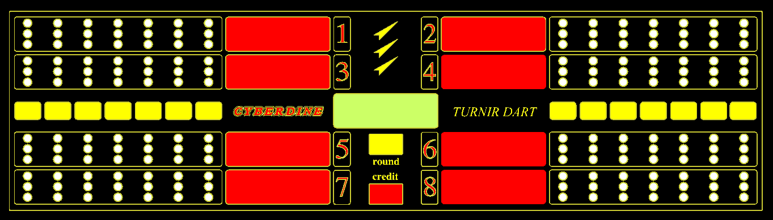
4.4. DISPLAY

Diagram 7 – Display format

On the diagram 7. you can see the display (because of printing these Guidelines are not the same in reality) which is optimised, which provides all of the necessary information to the player eg. About the number of points achieved in a single round, about the number to be hit in order to complete the game, OPTIONS which are chosen for the game, chosen numbers of the Cricket game, credits …. Along all of this the attractive design of the display has not being forgotten as well as the great visibility and readability.
Remaining arrows
Round (circle of GAMES)
Current number of points (TEMPORAL) before GAME commencment name of the GAME

Credit amount

Number of points for Player number1.
Closed numbers (CRICKET) before GAME commencement name of the GAME options

0

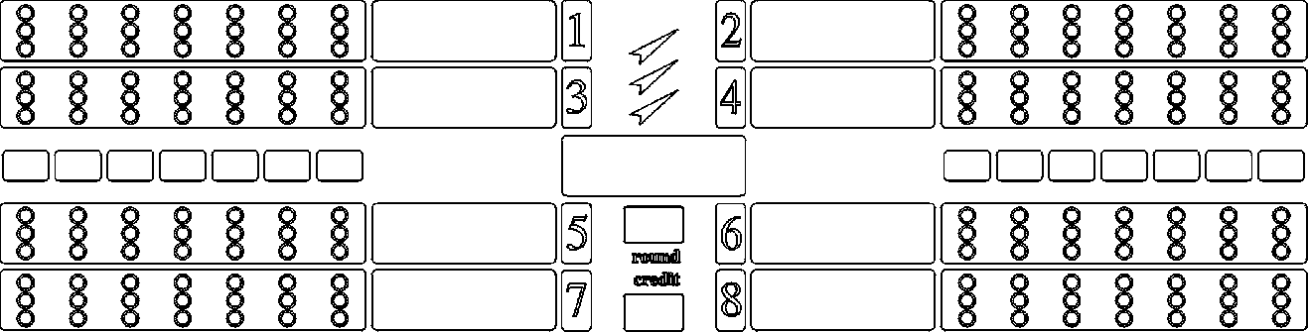

ra
nd
om
C r i c

0

0 5

4.5. Slot

In a standard version i CYBERDINE TOURNAMENT DART BOARD tokens which are provided are ALBERICI AL03_1 K xx.
ALBERICI AL03_1 K xx is an electronic token and a creditor which can be programmed on the initial device without any additional equipment. Programming is very simple and the guides are very simple and the guides are are located on the device. Token card has 6 channels and can be programmed for 12 different types of coins and tokens.

5. MICROSWITCHES (DIP SWITCH)

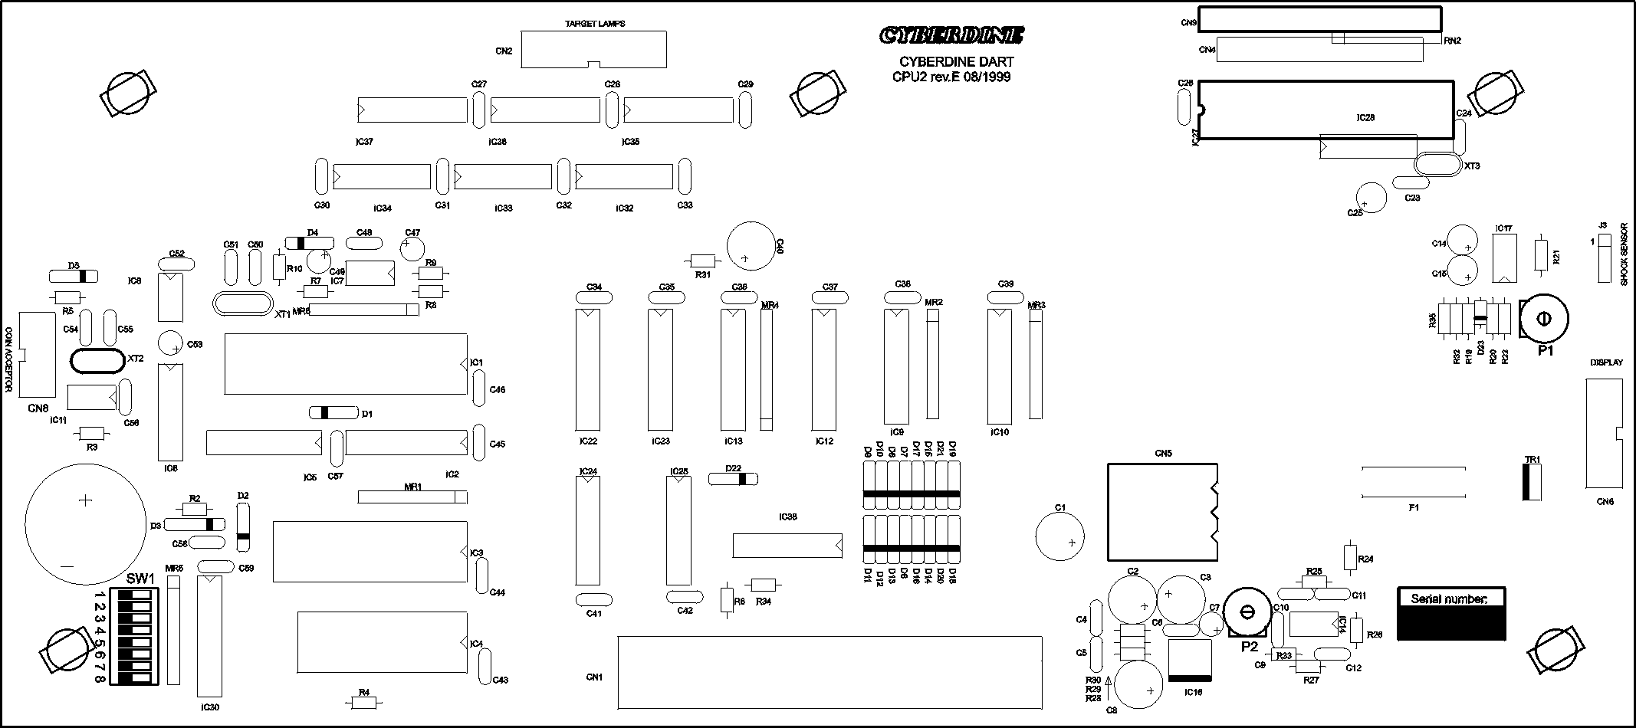
Many functions of the electronic dart board can be modified on the field by the User. This is the reason being using the microswitches. To correctly adjust Your device, please carefully read the following pages and follow the written procedure.
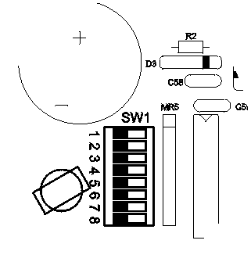
OFF ON
On the CPU board on the lower left corner the 8 microswitches are located.
They are used to enter the various menus (test, parameter setup...). They have two positions, ON or OFF. In the ON position the microswitch is active, and in the OFF position it is turned off. In order to enter the one of the following menus, we have to we have to turn off the device and turn the desired microswitch for a desired menu in th ON position and then turn on the device:
1. Test Menu | 5. Auxillary Bookkeeping
2. Statistics | 6. Tournament mode
3. Attract | 7. E-eprom initialisation
4. Main Bookkeeping | 8. Parameter setup

5.1 TEST MENU
It is possible at any time to set the parameters by the manufacturer ( in the case of unprofessional handling the modifications or if the undesireable values or if the procedure are forgotten) initializing E-eprom and RAM so that the unit turns off, microswitch number 7 is set to ON position and the unit is powered on again. Then it is required to press the button Roulette and hold it for 3 seconds, until we hear a short sound signal. By this process predefined parameters are set. Factory defined parameters are defined in the Paragraph 5.8
In order to enter the TEST menu it is required to turn off the unit, microswitch number 1 set it to the ON positionand then turn the unit ON again. In the test menu we can check the unit functionality and the peripheral units and the certain segments. When we have activated the test menu, (microswitch number 1 placed in the ON position) a printout on the display shows “test target”, and buttons Hi Score, Scram and Double Out start to blink. With these buttons we move through the menu. The button Double Out is used to open and close a desired submenu. The button Hi Score is used to move in a forward direction, and the button Scram for moving backward in the menu or the submenu. Only during the option “test light” Button Player uses for moving through the submenu because with the buttons Hi Score and Scram control the submenu.
T a r g
T e s t
e t
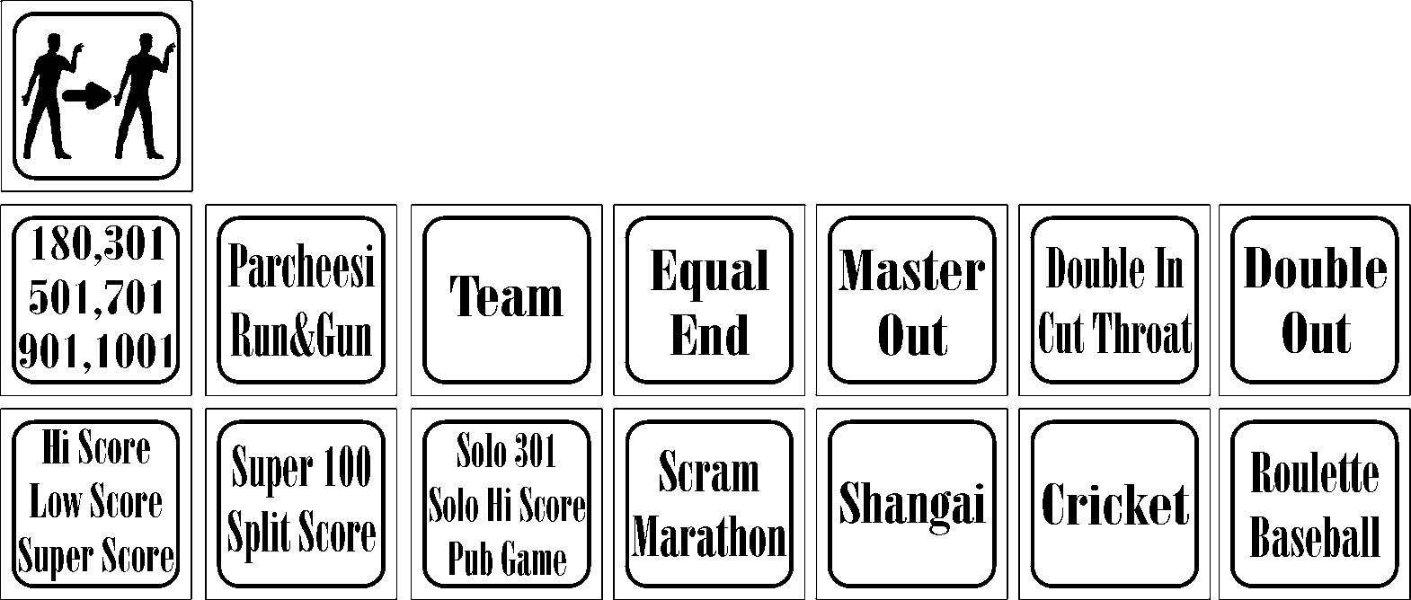
We have 6 submenus in the test mode:
- test target
- test light
- test button
- test infra
- test tup
- test credit
T e s t
T a r g
e t
5.1.1. Test target
During the entry in the test menu the display shows “test target”. In order to test the target we have to press the button Double Out. Within this sub-choice it is possible to test the functionality of connectivity of all target segments with the matrix sensor (foil) device. The target is tested by pressing on the certain segments on the target board. Display ROUND numbers 1,2,3 and 4 shows on the segment is single, double, triple or quadriple, whilst the exact number of segments can be seen on the CREDIT display. By the completion of the test by pressing the button Double Out we are exiting the submenu.
T e s t
l i g h
T
5.1.2. Test light
With the button Hi Score we move forward and when the display shows “test light” we press the button Double Out to enter this submenu. Within this submenu we can test the functionality of lighting of all led diodes and the unit lights. In the submenu we move with a button Players, whilst with Hi Score and Scram we continue with the test forward or backward.
Types of the tests are as follows:
- all light signals turn on
- testing the segments on the display
- testing certain segment lines
- testing the button lights
- testing of vertical and horizontal diode lines on the display
- testing the lights on the dart board, one by one
When we complete the testing of the light signals, in order to exit the submenu, we have to press the button Double Out.

5.1.3. Test button
T e s t
B u t t
o n
With the button Hi Score we move forwards and when the display shows “test button” we press the buton Double Out. When we choose the submenu “test button”, by pressing the button Double Out, all buttons start to flash. The buttons lose their function for moving through the submenu, except the button Players which is used to exit from the submenu. During by pressing any button, except the button Players, on the display, it will be shown the printout of type of the button, and that Button must be lit. With the button Players we are exiting the submenu.

5.1.4. Test infra
T e s t
I n f r
a
With the button Hi Score we move forwards and when the display shows “test infra” we press the button Double Out. During the activation of the infrared sensor a short sound signal will sound and the light on the FAULT will be lit. If the sensor doesn’t function the best because of external effects (light tiles, some interference in the surrounding display a false detection or similar sl.) or unprofessional handling, it has to be adjusted. If the sound is continuously on, then the sensor is too strong, and if the sensor doesn’t activate in the vicinity of the black circle around the target, then it is too weakthen the trimmer has to be adjusted on the sensor itself so that the sound signal is heard in the vicinity of the black circle under the dart board.Sensor is increased by moving it ina cloclwise direction, and in the opposite direction the sensor sensitivity is weakened. With the button Double Out we are exiting the submenu. For the other adjustments of the infra sensor, See paragraph 5.8.19.

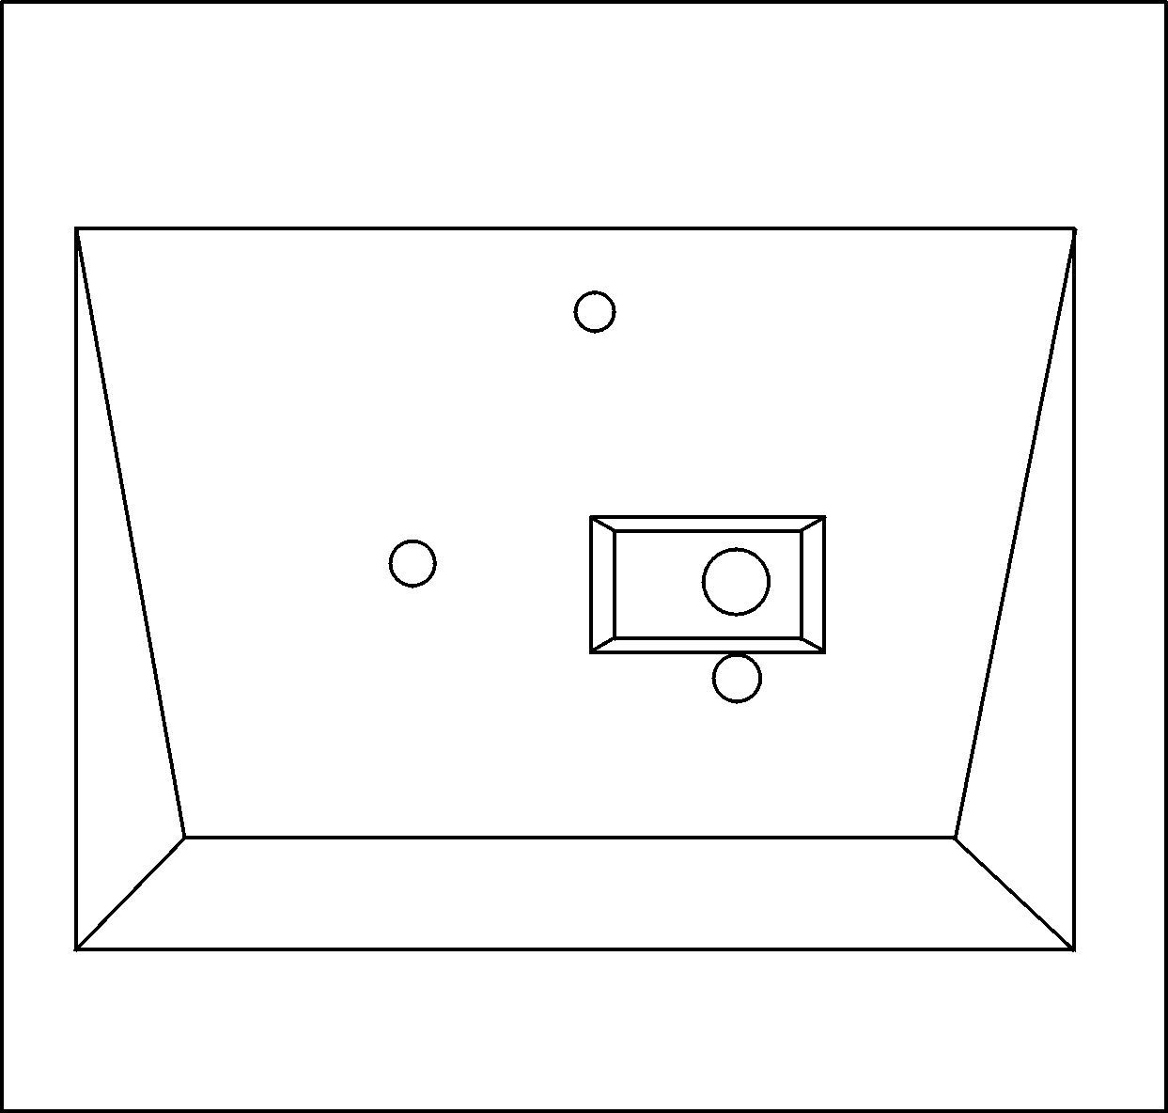
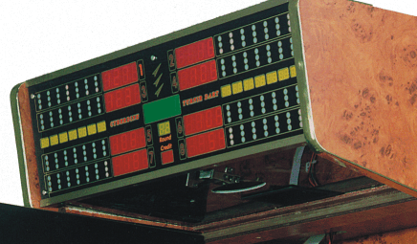
Trimmer position for the regulation
Blue LED
Infra sensor
Red LED
Infra sensor position
Infra sensor
5.1.5. Test tup

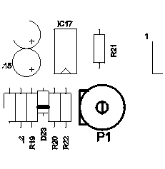
With a button Hi Score we move towads the frontand when the display shows “test tup” we press the button Double Out. During activation of tup sensora (senszora of missed arrows), by hitting with arrows in the black circle around the target, a short sound signal will be heard and the FAULT lamps will light up. If tup sensor is too sensitive or not sensitive enough, it can be adjusted on the CPU printed circuit boardi. Trmimer for regulation of sensitivity (P1) is located in the upper right corner of the CPU printed circuit board, the strengthening of the sensitivity of the sensor is adjusted by turning it in a clockwise direction, and in the opposite direction it is weakened. If the tup sensor not possible to be adjusted and if the continuous sound signal is heard, we have to check the wire cable which must be grounded. With the button Double Out we are exiting fom the adjustments.
5.1.6. Test credit
With the button Hi Score we move towads the frontand when the display shows “test credit” pressing the button Double Out. During the key activation or tokena short sound signal will be heard and the FAULT light will appear. During the key testing or of the token credits won’t be turned on nor will be recorded in the bookkeepingor on the counter. With the buton Double Out we are exiting fom the adjustments.
T e s t
C r e d
I t

From the TEST MENU we are exiting by switching the microswitch number 1 in the OFF position.

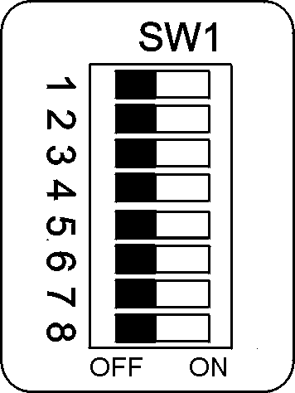5.2. STATISTICS

If the microswitch number 2 is located on the ON position we are entering this menu. This menu enables us to control the number of played games of each individual GAMES and its OPTIONS. By the buttons Hi Score and Scram we are moving forward that is back.

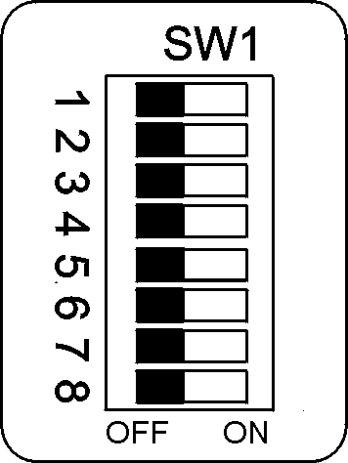
5.3. ATTRACT

If the microswitch number 3 is in the ON position then we can choose if we want the halogen light which light the target is continuously on or is disconnected, and lights up only when the game commences, then if we choose after a certain period of time when the unit is not used starts to play a melody to (Attract). In order to memorise desired parameters the unit has to be turned off and then turned on again.

5.4. MAIN BOOKKEEPING

If the microswitch number 4 is in the ON position on the display, a number of credits will be displayed. This electronic bookkeeping is the safe battery free double accounting system for the complete control of the assets. They cannot be erased and the details are continuously kept. On the first and second player display, a six figured electronic counter, all of the credits are shown keyed under the input number 1 (key), whilst on the fifth and the sixth player display, six figured electronic counter, all of the credits are shown keyed under the input number 2 (token). From the main bookkeeping we are exiting by switching the microswitch number 4 in the OFF position.

5.5. AUXILLARY BOOKKEEPING

If the microswitch number 5 is in the ON position on the display a number of credits will be displayed. This bookkeeping is auxillary and can be erased by holding the button Roulette for 5 sec. This bookkeeping can also be read without opening the unit and switching the microswitch number 5 in the ON state. In order for the auxillary (waiters) bookkeeping be read, it is only required to turn the unit off, press the button Equal and again turn on the unit, and on the display a state of the credit will be displayed. When the Equal button is released, the unit immediately returns to the demo mode or in the exploitation if it has a credit present. Then the state is externally read and the bookkeeping cannot be erased. Erasing the status is possible only if the microswitch number 5 is switched to the ON mode. This method is for the simple sight of personnel and that is why this bookkeeping is called waiters On the first and second player display, a six figured electronic counter, all of the credits are shown keyed under the input number 1 (key), whilst on the fifth and the sixth player display, six figured electronic counter, all of the credits are shown keyed under the input number 2 (token).From the auxillary bookkeeping cen be exited by switching the microswitch number 5 in the OFF position.

5.6. TOURNAMENT MODE

Microswitch number 6 we set the unit on the TOURNAMENT mode. Over here there is a possibility to play the game to an unlimited number of rounds, thence disconnection of the automatic display of numbers for the possibility of dropping the number to a zero. All of the sound effects are disconnected for the numbers valued up to the figure of 50.

5.7. E-EPROM INITIALISATION

Initialisation of E-eprom and RAM is possible if the microswitch number 7 is in the ON position. Initialisation provides the factory settings which have defined parametersand are described in the section 5.8., in case of handling by the unqualified personnel. In order for the unit to be initialized it is necessary to press the Roulette button and hold it for 3 secondsuntil a short sound signal is heard. After the sound signal parameters are set on the standard values. During initialization the main bookkeeping is not erased, but during the initialization of the RAM a current state of the credit is erased on the display.

5.8. PARAMETER SETUP

Within this menu we can adjust various values tied by the credit price, length of the games, prize game and others. When we adjust the microswitch number 8 in the ON state then we activate this menu. On table 1 the factory defined parameters are shown which can be set by initialization of the E-eprom, (see paragraph 5.7).

Table 1
1. | PRICE ADJUST | see table 2
2. | HAPPY PRICE | see table 2
3. | ROUND ADJUST  -Hi, low,super score  -Cricket  -180, 301, 501, 701, 901, 1001,solo,roul., … | 07  20  05,10,15,20,25,30…
4. | HAPPY ROUND  -Hi, low,super score  -Cricket  -180, 301, 501, 701, 901, 1001,solo,roul., … | 07  20  05,10,15,20,25,30…
5. | SETUP CLOCK | Sat
6. | SETUP HAPPY HOUR | start 0 0  end 0 0
7. | BONUS CREDIT | 0
8. | BONUS PERCENT | 0
9. | TIME LIMIT | 00
10. | COUNTER PULSES | 00
11. | SWITCH CREDITS | 01
12. | TIME CREDITS | 0
13. | PUBLICITY | Cyberdine TOURNAMENT darts
14. | LOTTERY | 10
15. | OPTIONS REMEMBER | ON
16. | DEMO SOUND | ON
17.* | QUATTRO MODE ON | ON
18. | RETURN DART | ON
19. | BULL VALLUE | 2
20. | PLAY OFF | ON
21. | MAIN LAMP | 16
22. | BACK LIGHT | 2
23. | INFRA ADJUST | 02
24. | ACCEPTOR TIME ADJUST | 01
* - only on the QUATTRO models

In this menu we are orienting as in the test menu, with the buttons Player, Hi Score, Scram and Double Out. button Double Out is used for opening the desired changes, its closure and confirmation, choosing new value. Button Hi Score is used to move forward and increasing the value, a Button Scram for moving backwards and reducing the value through the menu and submenu. Only in the option “price adjust” and “round adjust” Button Player is used in the submenu because with the buttons Hi Score and Scram we change the values.
5.8.1. Price Adjust
S E T U

P

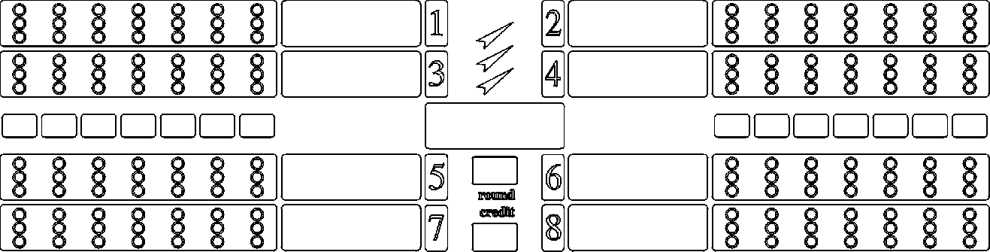
P r i c

e

A d j u

S t

When we switch the microswitch number 8 in the ON position, (the unit has to be firstly disconnected then turned on again) on the upper display a “price adjust” will be displayed. By pressing the buttons Double Out we are opening a submenu. In the submenu we ar moving (changing GAMES) by the button Players, and the buttons Hi Score and Scram we are changing the price of the games. When we have adjusted the values by the Double Out button we confirm the new choices and are closing the submenu. In the table 2 we have the normal price of the games which are set during the initialisation phase.

Table 2
180 | c ½
301 | 1
501 | 2
701 | 3
901 | 3
1001 | 4
CRICKET | 2
HI - SCORE | 1
LO - SCORE | 1
SUP - SCORE | 1
SHANGAI | 1
BASEBALL | 1
ROULETTE | 1
SCRAM | 2
SUPER 100 | 1
PUB | c ½
SOLO HI SCORE | 1
SOLO 301 | 1
MINI MARATHON | 2
MARATHON | 4
SPLIT SCORE | 1
DOUBLE IN | 0
DOUBLE OUT | 0
DOUBLE IN OUT | 0
MASTER OUT | 0
5.8.2. Happy Price
P

S E T U

h a p p

y

P r i c

e

By the button Hi Score we are moving the menu forwards until we see a sign “happy price” then we have to press the button Double Out. By pressing the button Double Out we are opening a submenu. In the submenu we are moving (changing GAMES) by the button Players, and by the buttons Hi score and Scram we are changing the price of the games. When we have adjusted the values with the button Double Out we are confirming a new choice and are closing the submenu. Standard price value is shown on the table 2. In order to confirm and store the values we have to press the button Double Out.

5.8.3. Round Adjust
P

S E T U

R o u n

d

A d j u

s t

By the buttonHi Score we are moving the menu forwards until we see a sign “round adjust” By the button Double Out. By pressing the button Double Out we are opening a submenu. In a submenu we are moving (changing GAMES) by the button Players, and by the buttons Hi Score and Scram we are changing the number of game rounds. When we have adjusted the values by the button Double Out we are confirming a new choice and closing the submenu.

5.8.4. Happy Round

R o u n

d

H a p p

y

P

S E T U

By the button Hi Score we are moving the menu forwards until we see a sign “happy round” By the button Double Out. By pressing the button Double Out we are opening a submenu. In a submenu we are moving (changing GAMES) by the button Players, and by the buttons Hi Score and Scram changing the number of the game rounds. In a submenu we are changing the number of rounds of certain GAMES in a defined time frame (happy hour). This time frame is determined by choosing Setup Happy Hour. When we have adjusted the values by the Double Out button we confirm the new choice and are closing the menu.

5.8.5. Setup Clock
P

S E T U

C l o c

k

S E T U

P

By the button Hi Score we are moving the menu forwards until we see a sign “setup clock” then we have to press the button Double Out. By pressing the button Double Out we are opening a submenu. Within this subchoice we are adjusting the exact time of the hour. In a submenu we are moving (adjusting the hour, minite, seconds) by the button Players, and by the buttons Hi Score and Scram we are changing the hour, minute, seconds. When we have adjusted the values by Double Out button we are confirming the new choice and are closing the submenu.

5.8.6. Setup Happy Hour
H a p p

Y h r

P

S E T U

S E T U

P

By the button Hi Score we are moving the menu forwards until we see a sign “setup happy hour” then we have to press the button Double Out. By pressing the button Double Out we are opening a submenu. Within this subchoice beginning and the end of the happy hour duration. We then open a submenu and are moving (adjusting the hour, minute, seconds) by the button Players, and the buttons Hi Score and Scram we are changing the hour, minute, seconds. When we have adjusted the values by the button Double Out we are confirming a new choice and closing a submenu.
5.8.7. Bonus Credit
C R E D

s
b o n u
S E T U

P

I T

By the button Hi Score we are moving the menu forwards until we see a sign “bonus credit” then we have to press the button Double Out. This option defines the limit when we are going to share the bonus, credits ie. On which anount of credit are we adding a bonus. If for an instance a chosen number 10 without the percentage of the bonus (See paragraph 5.8.8.) till 10 credits are shared the bonus is not given out until the inserted value of money copmlies with the 10 credits or more, then the bonus is rewarded depending on the values adjusted by the paragraph 5.8.8. Certain values are 2 to 50 buttons Hi Score and Scram reducing or increasing the borderline of the creidit In order cto confirm and save the value we have to press the buttons confirm and save the valies we need to press the Value to save the value we have to press the button Double Out..

5.8.8. Bonus Percent
p e r c

s
b o n u
S E T U

P

e n t

By the button Hi Score we are moving the menu forwards until we see a sign “bonus percent” then we have to press the button Double Out. By this option we are confirming the credit in percentages, like for eg.20 % bonus gives 2 credits on 10 inserted, 3 on 15 inserted in etc.. Possible are from 0 to 30 by increments of 5. By buttons Hi Score and Scram we increase or decrease the value of the bonus. In order to confirm and save these values we have to press the button Double Out.
5.8.9. Time Limit
T i m e

L i m i

t

S E T U

P

By the button Hi Score we are moving the menu forwards until we see a sign “time limit” then we have to press the button Double Out. Within this subchoice we can change and confirm tha maximum time the player has toeach arrow into the target. With the buttons Hi Score and Scram we are changing the time from 00 to 60 secondsi, increasing it by 10 seconds. Time can be seen on a temporary results display (TEMPORAL). If we choose a zero (00), then for all the arrows we have unlimited time. When we have determined the time limit, in order to confirm and save the values, we need to press the button Double Out.

5.8.10. Counter Pulses
P u l s

E s

S E T U

P

C o u n

T e r

By the button Hi Score we are moving the menu forwards until we see a sign “counter pulses” by pressing the button Double Out. Within this subchoice we can change number of turns of the mechanical counter in reference to the number of credits from 0 to 10. The number shows how many credits from 10 will not be shown on the mechanical counter. Like for eg. Number 3 says that it will from 10 inserted credits will be counted only 7. If number 10 is chosen, the mechanical counter is disconnected. Then we have set the wanted value, in order to confirm and save, we have to press the button Double Out.

5.8.11. Switch Credit
S w I t

S E T U

P

C h

By the button Hi Score we are moving the menu forwards until we see a sign “switch credit” pritisnemo tipku Double Out. Within this subchoice we can change and determine the number of credits for every impulse accepted by turning the key. With the buttons Hi Score and Scram we are changing the number of credits according to the impulse, from 1 to 10. The value of the credit is shown on the temporary results display (TEMPORAL). In order to confirm and save the values we have to press the button Double Out.
I t

C r e d

5.8.12. Time - Credits
C R E D

T I M E
S E T U

P

I T

By the button Hi Score we are moving the menu forwards until we see a sign “time credits” pritisnemo tipku Double Out. After this option we determinehow many minutes is the value of a single credit. In this case all the GAMES are free of charge but the time is charged GAMES. If a chosen value is 0, GAMES cost as per the price table (See paragraph 5.8.1 tablice 1 i 2). By the buttons Hi Score and Scram we choose how many minutes is a value od a sinle credit. Possible valuse are from 0 to 30 in single steps. In order to confirm and save the values we have to press the button Double Out.

5.8.13. Publicity
y

I c i t

P u b l

S E T U

P

By the button Hi Score we are moving the menu forwards until we see a sign “publicity” and pressing the button Double Out, and then the button Players to see a current list on a display. Publicity is the option in which the owner has a possibility to display ads from 28 letter or number places. Advertisement is shown in the demo mode. By the button Double Out we enter to this option. With the button Players we choose the places for the letters or numbers, and with the buttons Hi Score and Scram we chose the letters or numbers. In order to confirm and save the values we have to press the button Double Out.
5.8.14. Lottery
S E T U

P

By the button Hi Score we are moving the menu forwards until we see a sign “lottery” pritisnemo tipku Double Out. Within this subchoice we can activate the lottery option. If it is activated after every GAME a certain number can be seen on a TEMPORAL display. If the number on a TEMPORAL display is identical to the player’s number, one or more, then the player or the players receive a prize credit. A player gets as much as credit as this game is worth eg. If he played 301 he is going to receive a single credit, but if the player has played 701the player is going to receive 3 prize credits. Prize credits are not added to the bookkeeping. With Hi Score and Scram we choose between 00 and 30. With 00 we disable the lottery option, and with choices of other numbers we choose a percentage of the chance gaining prize credits. Zero 00 and one 01 can be seen on a TEMPORAL display. Then we have completed th lottery programming. In order to confirm and save the values we have to press the button Double Out.
L o t t

E r y

5.8.15. Option Remember
S E T U

P

R e m e

O n

O p t i

M b e r

By the button Hi Score we are moving the menu forwards until we see a sign “option remember” by pressing the button Double Out. Within this subchoice we can turn on or off automatic memory option which we have chosen for a game during the completion of the GAMES.order to confirm and save the values we have to press the button Double Out.
5.8.16. Demo Sound
S o u n

D e m o

S E T U

P

d

By the button Hi Score we are moving the menu forwards until we see a sign “demo sound” we press the button Double Out. In this subchoice we have the opportunity to turn on or off the demo melody when the unit is in the demo mode. In order to confirm and save the values we have to press the button Double Out.

5.8.17. Quattro Mode On*
M O D E
R O
Q A T T
S E T U

P

O n
By the button Hi Score we are moving the menu forwards until we see a sign “quattro mode on” by pressing the button Double Out. If this option is turned (ON) from the beginning of every game, the quattro option is turned on and if it is if it is desired it can be manually disabled by pressing the button QUATTRO, iIt is the same if the option is to be diconnected turned (OFF) at the beginning of every game, and if it is manually enabled and if it is manualy required by pressing the button QUATTRO. In order to confirm and save the values we have to press the button Double Out.

5.8.18. Return Dart
D a r t

R n

R e t u

S E T U

P

By the button Hi Score we are moving the menu forwards until we see a sign “return dart” by pressing the button Double Out. During the GAMES program it enables a return of an single arrow in every round, , By pressing the both buttons: Hi Score and Quattro. This option is enabled in order of accidental activation of a tup sensor.. If the chosen value is OFF option returning the arrow is deactivated, and with ON activated In order to confirm and save the values we have to press the button
Double Out.
5.8.19. Bull Value
S E T U

P

e

B u l l

V a l u

By the button Hi Score we are moving the menu forwards until we see a sign “bull vallue” by pressing the button Double Out. By this subchoice adjusting the value of the centre. With the buttons Hi Score and Scram we are adjusting the values from 01 to 04. There are 4 combinations of the values:
01 – both fields are worth 25
02 – outside field 25, a double 50
03 – both fields 50
04 – outside field 50, a double 100
In order to confirm and save values we press the buttons Double Out.

5.8.20. Play Off
P

S E T U

p l a y

o f f

By the button Hi Score we are moving the menu forwards until we see a sign “play off” by pressing the button Double Out. Play off is the option which enables enthusiasm for a better position of the player. In this case the players at the end of the game have the same amout of points that they enjoy, each one with one arrow, and a better player is the one with the highest result. You can play off for any position, for the first, second, .. or the last. JOnly from the end in case of activating the OPTIONS EQUAL, there is a count of arrows from which the player has completed the game. If one player has finished the game with the first, and the other with a second or a third arrow the winner is the the first player and they don’t play off if they have the same amout of points (000). With the choice of the value turned ON we activate this option. And with the OFF choice we turn it off. In order to confirm and save the values we have to press the button Double Out.
5.8.21. Main Lamp
S E T U

P

By the button Hi Score we are moving the menu forwards until we see a sign “main lamp” by pressing the button Double Out. This subchoice enables us to adjust the intensity of the lighting from the main halogen lamp which lights up the target. By the buttons Hi Score and Scram we increase or reduce the intensity from 04 (dark) to 16 (light). In order to confirm and save the values we have to press the button Double Out.
M a i n

L a m p

5.8.22. Back Light
S E T U

P

By the button Hi Score we are moving the menu forwards until we see a sign “back light” by pressing the button Double Out. This subchoice enables us to adjust the intensity of the lamps adjusting the intensity of the light lamps around the target and the and the lights on the buttons. The buttons Hi Score and Scram we increase or reduce the intensity from 02 (dark) to 10 (light). In order to confirm and save the values we have to press the button Double Out.
B a c k

L i g h

t

5.8.23. Infra sensor
S E T U

P

i n f r

a

a d j u

s t

By the button Hi Score we are moving the menu forwards until we see a sign “infra adjust” by pressing the button Double Out. In the frame of this subchoice and deactivating the infrared sensor for the automatic change of the player. The offerings are OPTIONS from 00 to 05 with increments of 1. Option 00 deactivates IR sensor and then during the transfer of the playerduring the GAMES is performed by the manual depression of the button Players. OPTIONS from 01 to 05 activate IR sensor with the various time constants for the automatic change of the players. The fastest option is 01, and the slowest is 05. When we adjusted the desired value by pressing the button Double Out we confirm the option and close the option.

5.8.24. Acceptor
S E T U

P

A c c e

P t o r

By the button Hi Score we are moving the menu forwards until we see a sign “acceptor” pritisnemo tipku Double Out. Inside this subchoice we can change and confirm the method of coin acceptance (money) in this device. This device is setu up so it can be integrated with all the combinations to accept credits (Key or tokens) which are familiar to us. The speed of money acceptance is changed by the buttons Hi Score and Scram. The method of accepting the coins can be seen on the TEMPORAL display, and can be chosebn between the optionsđu opcija 1,2,3. When we have completed the programming of credit acceptance, we can then confirm and save the values we have to press the button Double Out.

5.9. SOUND

The sound of the demo melody and the sound effects can be adjusted as desired. In order to amplify the sound you have to turn the P2 trimmer towards the side of the arrow clockwise and in case you want to reduce the sound you will have to turn the trimmer counterclockwise.
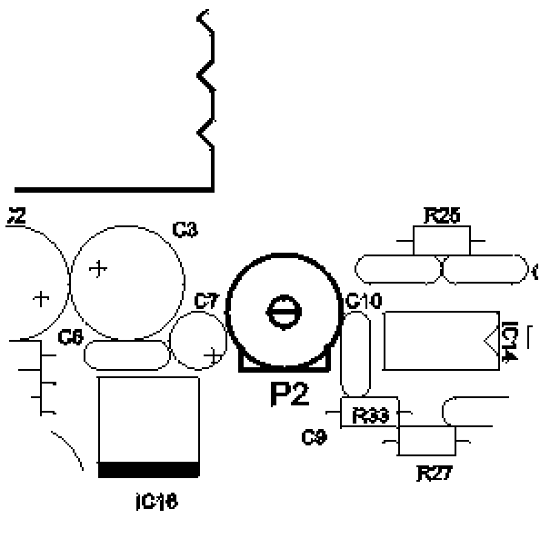

6. GAME RULES

180,301,501,701,901,1001 (pressing the button 180 more than once)
- It is a game for 1 to 8 players playing independently or in the team. The players start a game with 180/301/501/701/901/1001 points. Every arrow deducts points towards 0. The first player who drops to a 0 value is the winner. By going over the zero value is called a BUST and the player returns to the result of a previous round and again tries through a next round. Standard of the rounds are: 180 - 5, 301 -10, 501 - 15, 701 – 20, 901-25, 1001-30 rounds, three arrows per round.

PARCHEESI
- It is a game for 1 to 8 players playing independently or in the team. The players start from the zero value. The game closes exactly on 180, 301... In case of the overturn of the number because of BUST and because of the exiting numbers 180, 301… the overturned nimber is deducted. Eg. The player who has 178 and hits 17 is coming back to a value of 165 (178+17=195; the overturn is 15; 180 – 15= 165) When a layer comes to the exact number of another player, ge returns to a zero value. Standard value for 180 is 5 rounds , and for 301 is 10 rounds, three arrows per round.

CRICKET
- It is a game for 1 to 8 players playing independently or in the team. The players start from the zero value. The players are hitting the numbers from 15 to 20 and the centre. The number is closed when it is hit 3 times (quadriple value is given for 4 hits, triple valuse is given for 3, double for 2, and a single for 1). By hitting your own closed number we are getting the points close that number. The first player to close all the numbers and the centre and has the highest point score is the winner, and to the other players the filled points are added (3 points to the completed numer 17 gives 51 points, but if he has ony 2 poits filled he gains 34 points) with his total result. The remaining players are status ranged by the total result (the addition of the completed points and the scores). As the player has the higher number he is in a better status. The standards value of the round is 20, three arrows per round.
CRICKET CUT THROAT (Cricket + Cut Throat)
- Same rules apply as for the Cricket excepth that the points are given to the players who haven't closed the numbers, and the winner is the player that who closes all the numbers and the centre, and has the lowest result.

CRICKET MASTER (Cricket + Master Out)
- Same rules apply as for the CUT THROATH CRICKET , in case of hitting the numbers below the value under 15 or the numbers all the players have closed, the points are given to the person who has the next throw By missing the target, it is scored as if the centre is hit.

CRICKET KILLER (Cricket + two times Master Out)
- Same rules apply as for the CUT THROAT CRICKET , with the exception that by hitting a number which is a closed one the number of points is given to the competitor depending on how many times they have hit this number eg. If someone has hit a number 10 no one gets 30 points if they have hit number 10 twice and needs only one hit to close the number to get 10 points.

CRICKET PICK-IT (two timesCricket)
- The same rules apply as for the CRICKET and CRICKET with the abovementioned options, with the exception that the players choose themselves the 7 numbers by pressing the segments on the target..
CRICKET RANDOM (3 times Cricket)
- Same rules apply as for CRICKET and CRICKET with the abovementioned options, with the exception that the Dart Board itself chooses 7 numbers to which have to be closed.
CRICKET CRAZY (4 times Cricket)
- The same rules appy as for the CRICKET RANDOM, with the exception that the Dart Board itself chooses 7 numbers which can be closed in the one round and if in that round you don’t close a certain number, in the following round the Dart Board will change the values.

HIGH SCORE
- The players start from the zero value. The player with the highest result is the winner. The standard value of the rounds is 7, with 3 arrows per round.
.
LOW SCORE (2 times High Score)
- The players start from the zero value. The player with the lowest result is the winner. In case of a hit outside the target the player is fined by losing 50 points. The standard value of the rounds is 7, with 3 arrows per round.
.
SUPER SCORE ( 3 times High Score)
- The rules are as for the High Score except that the hits in the double, triple and quadriple segments are counted (only if the QATTRO option is enabled). The standard value of the rounds is 7, with 3 arrows per round.

SPLIT SCORE
- The players start the game with 40 points. The numbers are hit by the following sequence: 15, 16, either double segment, 17, 18, either triple segment, 19, 20, centre. For every number we have 3 arrowsand if the numbers are not hit by 3 tries, the score is halved. In case of a hit we gain the the number of points that we have successfully hit. The winner is the one with the highest amount of points gained. The numer of the rounds is 9 with 3 arrows per the round.

SUPER 100
- The players start from the zero value. The surrounding lightrotate in a clockwise direction and the center is also counted as a score. The player must hit one of the three lit segments or the centre itself. By hitting the first segment you gain 10 points, in the middle 5, and the last with 2 points. Hitting the centre itself contributes to 3 points, whilst the outside of he centre contributed to 1 point. By hitting the couble, triple or quadriple segment you multiply the points by 2, 3 or 4. The winner is the one who is the first to gain 100 points or the player with the highest number of points.

SHANGAI
- The player starts with a zero value. The targeted numbers are from 1 to 20, in an orderly manner, and in the end to hit the centre. The player cannot hit another number until he hits the first onei. The winner is the one with the highest number f the points under the condition that the points are calculated like in the a ’01 GAMES. Shangai is the current winning streak, and is achieved by a hit on the single, double, and triple field in one round (eg. 3 in the double, 4 in the single and 5 in the ripple is the Shangai). The value of the round is 7, three arrows per round.

SOLO 301, SOLO HI SCORE
- The game is for a single player only (rules as the common GAMES) with the exception that the device gives a Handicap Number from 00 to 99 which determines the level of the player.

PUB GAME
- Players start the game from zero. The game has only one round (three arrows). On the display number 10is shown and it is decreasing towards zero. The value of the hit of every arrow is multiplied by the current number on the display. As the player more accurately and quickly throws an arrow, the result becomes beter. The winner is the player with the highest number of the points.

SCRAM
- Game for 2 to 8 players. Every player throws 6 arrows except the first one on the first round, he throws 3 arrows in the first round ( only on the first round) and ends with 3 arrows (only in the last round) First player starts the game as a stoper (3 arrows) and closes the the numbers to the second player. Second player starts as a scorer (3 arrows) and collects points and becomes a stoper (3 arrows) and closes numbers to the third player. And the third player scorer (3 arrows) iand collects points, and then becomes a stoper (3 arrows) and closes points to the following player. Fourth closes to the fifth, fifth to the sixthe and so on unti the eighth who closes the first. Winner of the game is the one with the highest point score. Value of the round is z, three arrows per round.

MARATHON (2 times Scram)
- Players start from zero. Aims are lined to the centre of the target, then the numbers from 20 to 1. The shots are valid in the double segment. The winner of the game is the player who first reaches to number 1 or the one with the highest point score. Value of the round is 30, three arrows per round.

MINI MARATHON ( 3 times Scram)
- Same rules as for MARATHONA but only aiming for the centre and numbers from 20 to 10, and the game lasts for 15 rounds.

ROULETTE
- Players start from zero. On the start of the round, the unit determines the number for which all of the players shoot for in this round. A hit is scored by a single 1 point, a double 2 points, triple 3 points, and quadriple by 4 points. Winner of the game is the one with the highest point score. Value of the round is 7, three arrows per round are allowed.

ROULETTE DOUBLE

- Same rules as for the Roulette, but the points are given by hitting the double segments.

BASEBALL
- Players start from zero. They throw the numbers on this round, eg. In the first round they aim for number 1, in the second aim for number 2... Single shot is one point, double 2 points, triple 3 points, and a quadriple 4 points. The winner is the one with the highest number of points.
Valie of the round is 9, three arrows per round.

DOUBLE IN (180 - 1001)
- subtracting of the points when a double segment is hit by either number or double centre.
CUT THROAT (CRICKET)
- Option for CRICKET, points are given to the players who didn’t close the number, the winner is the player with all of the numbers closed and the least number of points.
DOUBLE OUT (180 - 1001)
- The player has to complete the game with the hit in the double segment or double centre.

MASTER OUT (180 - 1001)
- The player must complete the game with a hit on a double, triple or quadriple segment (if the QUATTRO option is enabled).

EQUAL (180 - 1001)
- Fair Play option enables the players, that all players play the same number of rounds. When a certain player completes the game, other players play this round till the end of the game.

END (180 - 1001)
- Fair Play option enables the players to play the game to the last roung or when all the players don’t finish the game.

RUN AND GUN
- Valid for GAMES 180 - 1001 and HIGH SCORE.
The time availability is from 30 to 180 seconds depending on choice of the GAMES without round limitations. The winner is the one who in the shortest period of time completes the game but if he/she didn’t complete the game within the specified time frame the winning person is the one with the lesser point score. In the High Score game the winner is the one with the highest point score.

QUATTRO
- In this option we include quadriple segment.

REMARK: During the GAMES time the player can stop an individual game and strart from the beginning the same game or start another game by simultaneously pressing both buttons at the same time: High Score, Super 100 i Roulette Baseball
- GAME COMBINATIONS

Procedure of the Choice games and the required options it is simplified to the ultimate borderline to simplify the Choice games. That is how during the beginning (after inserting the credits) the lights of all of the games are lit up. When the game is chosen the lights on the buttons are lit only on the required buttons which show the desired OPTIONS for this game.
5 0 1
ma

st

er

o

ut

05

GAMES Name

OPTIONS

Number of Credits

When the credit is inserted, (bank notes, coins or tokens žetoni or via the key – in our example shown above with 05 credits) buttons which show GAMES start lighting. Some buttons offer possibility of multiple choices, so by pressing a certain button a few times display the changes of the games are shown on TEMPORAL display. In our example by pressing the button 3 times 180, 301, 501, 701, 901, 1001 the name GAMES shows on the TEMPORAL DISPLAY (in our example 501). When the chosen game stays lit the buttons show OPTIONS for this game. OPTIONS can be chosen until the game starts. In our example it is important to press two out buttons Solo 301, Solo Hi Score, Pub Game and the chosen option stays on the CRICKET display. (In our example master out).
Izbor GAMES

Izbor OPTIONS

GAMES | OPTIONS | QUATTRO*
180  301  501  701  901  1001 | -DOUBLE IN  -DOUBLE OUT  -DOUBLE IN/DOUBLE OUT  -DOUBLE IN/MASTER OUT  -MASTER OUT  -DOUBLE IN/TEAM  -DOUBLE OUT/TEAM  -DOUBLE IN/DOUBLE OUT/TEAM  -DOUBLE IN/MASTER OUT/TEAM  -MASTER OUT/TEAM  -DOUBLE IN/EQUAL  -DOUBLE OUT/EQUAL  -DOUBLEIN/DOUBLE OUT/EQUAL  -DOUBLE IN/MASTER OUT/EQUAL  -MASTER OUT/EQUAL  -DOUBLE IN/TEAM/EQUAL  -DOUBLE OUT/TEAM/EQUAL  -DOUBLE IN/DOUBLE OUT/  -TEAM/EQUAL  -DOUBLE IN/MASTER OUT/  -TEAM/EQUAL  -MASTER OUT/TEAM/EQUAL  -DOUBLE IN/END  -DOUBLE OUT/END  -DOUBLE IN/DOUBLE OUT/END  -DOUBLE IN/MASTER OUT/END  -MASTER OUT/END  -DOUBLE IN/TEAM/END  -DOUBLE OUT/TEAM/END  -DOUBLEIN/DOUBLE OUT/  TEAM/END  -DOUBLEIN/MASTER OUT/TEAM/END  -MASTER OUT/TEAM/END  -TEAM  -EQUAL  -END  -TEAM/EQUAL  -TEAM/END  -RUN AND GUN  -RUN AND GUN DOUBLE IN  -RUN AND GUN DOUBLE OUT  -RUN AND GUN DOUBLE IN/OUT  -RUN AND GUN DOUBLE IN MASTER OUT  -RUN AND GUN MASTER OUT | FOR ALL THE GAMES IT IS POSSIBLE TO CONNECT THE QUATTRO OPTION EXCEPT FOR MARATHON AND MINI MARATHON
180  301  501  701  901  1001 | -PARCHEESI  -PARCHEESI DOUBLE IN  -PARCHEESI DOUBLE OUT  -PARCHEESI DOUBLE IN/OUT  -PARCHEESI DOUBLE IN MASTER OUT  -PARCHEESI MASTER OUT  -PARCHEESI DOUBLE IN TEAM  -PARCHEESI DOUBLE OUT TEAM  -PARCHEESI DOUBLE IN/OUT TEAM  -PARCHEESI DOUBLE IN MASTER TEAM  -PARCHEESI MASTER TEAM  -PARCHEESI DOUBLE IN EQUAL  -PARCHEESI DOUBLE OUT EQUAL  -PARCHEESI DOUBLE IN/OUT EQUAL  -PARCHEESI DOUBLE IN MASTER OUT EQUAL  -PARCHEESI MASTER OUT EQUAL  -PARCHEESI DOUBLE IN TEAM EQUAL  -PARCHEESI DOUBLE OUT TEAM EQUAL  -PARCHEESI DOUBLE IN/OUT TEAM EQUAL  -PARCHEESI DOUBLE IN MASTER OUT TEAM EQUAL  -PARCHEESI MASTER OUT TEAM EQUAL  -PARCHEESI DOUBLE IN END  -PARCHEESI DOUBLE OUT END  -PARCHEESI DOUBLE IN/OUT END  -PARCHEESI DOUBLE IN MASTER OUT END  -PARCHEESI MASTER OUT END  -PARCHEESI DOUBLE IN TEAM END  -PARCHEESI DOUBLE OUT TEAM END  -PARCHEESI DOUBLE IN/OUT TEAM END  -PARCHEESI DOUBLE IN MASTER OUT TEAM TEAM END  -PARCHEESI MASTER OUT TEAM END  -PARCHEESI TEAM  -PARCHEESI EQUAL  -PARCHEESI END  -PARCHESSI TEAM EQUAL  -PARCHEESI TEAM END | FOR ALL THE GAMES IT IS POSSIBLE TO CONNECT THE QUATTRO OPTION EXCEPT FOR MARATHON AND MINI MARATHON
HI SCORE
LOW SCORE
SUPER SCORE
PUB GAME
SUPER 100
SOLO
HI SCORE
SOLO 301
SCRAM
MARATHON |  | QUATTRO OPTION NOT POSSIBLE TO CONNECT
MINI MARATHON |  | QUATTRO OPTION NOT POSSIBLE TO CONNECT
SHANGHAI |  | FOR ALL THE GAMES IT IS POSSIBLE TO CONNECT THE QUATTRO OPTION EXCEPT FOR MARATHON AND MINI MARATHON
CRICKET | CUT-THROAT  TEAM  CUT-THROAT/TEAM  MASTER  MASTER/TEAM
ROULETTE | DOUBLE
BASEBALL

* - models with QUATTRO option
- SPARE PARTS

ELECTRONIC PARTS
Line number | Serial part number | Description
1. | 73001 | Printed circuit board CPU - complete
2. | 73012 | Display - complete
3. | 73004 | Printed circuit board under the target
4. | 34002 | Power supply
5. | 73009 | TUP sensor - complete
6. | 73013 | Infra sensor - complete
7. | 65005 | Speaker
8. | 32003 | Button
9. | 65006 | Counter
10. | 71001 | Chip slot
11. | 71000 | Plastic mask for a chip slot
12. | 73005 | Wire form
13. | 64002 | Cable with a 20 pin Connector
14. | 64003 | Cable with a 14 pin Connector
15. | 64008 | Cable with a 10 pin Connector
16. | 64001 | Wire Cable 220 V
17. | 62019 | Cable carrier

TARGET
Line number | Serial part number | Description
1. | 93001 | Target - complete
2. | 72002 | Target – complete with the plastic
3. | 62005 - 1 | Single sector - red
4. | 62005 - 2 | Single sector - blue
5. | 62006 - 1 | Double sector - redi
6. | 62006 - 2 | Double sector - plavi
7. | 62007 - 1 | Triple sector - red
8. | 62007 - 2 | Triple sector - blue
9. | 62008 | Bullseye outer ring - blue
10. | 62009 | Bullseye inside - red
11. | 62010 | Spine
12. | 62001 | Foil for the target
13. | 61001 | Rubber for the target
14. | 62003 | Null sector 1/5
15. | 51004 | Target background
16. | 51005 | Wooden circle
17. | 43000 | Screw 5x60 mm
18. | 44002 | Support board 5x15x1,5 mm
19. | 43023 | Screw 4,8x16 mm
20. | 43006 | Screw 3x12 mm
21. | 42004 | Wing nut M5

LIGHTS
Line number. | Serial part number | Description
1. | 65013 | Carrier for the halogen light - complete
2. | 65001 | Neck for the halogen lamp
3. | 41000 | Halogen lamp neck carrier
4. | 41001 | Halogen lamp carrier
5. | 65002 | Halogen Light
6. | 65012 | Light T5
7. | 65016 | Light T10 (for buttons)
8. | 65011 | Neck for a lamp T5

MECHANICAL PARTS
Line number. | Serial part number | Description
1. | 51003 | Box
2. | 41013 | Hinges for the black box
3. | 51006 | Door - complete
4. | 51007 | Door - wooden
5. | 62030 | Door - plexi
6. | 41005 | Hinges for the Door
7. | 41006 | Carrier hinges
8. | 41012 | Legs
9. | 43034 | Screw M8x40
10. | 42003 | Nut M3
11. | 44001 | Support M3
12. | 43001 | Screw M6x30 mm
13. | 43003 | Screw 4,2x13 mm
14. | 43014 | Screw 3x12 mm
15. | 62016 | Plexi – game rules
16. | 62029 | Plexi ispod halogene lampe
17. | 62031 | Plexi lower part – black box
18. | 71000 | Plastic for the Token
19. | 63000 | Snaplock - contact
20. | 63001 | Snaplock - long
21. | 63002 | Snaplock - short
22. | 65008 | Door from the cash box

9. PROBLEMS AND SOLUTIONS (TROUBLESHOOTING)

Although the quality of this unit is strictly controlled and we from CYBERDINA can guarantee its unparallel functionality from the point of dispatchment from the factory (to which is stated in the warranty statement of our products), there is always a probability that something will fail during the transport. Although the unit is with movable parts, it is not spared from the consumables such as (lights, switches, …). On the unit there are certain items that a lay person can fix. Here we have a table which can be used to help to identify the fault which in turn can determine a fault which could be the most possible cause of the dart board not to function properly. In either case you can turn to our Service Department.

PROBLEM | POSSIBLE CAUSE | SOLUTION
Dart Board doesn’t work | Dart Board is not connected on power cable | Connect the Dart Board via a Cable which is located in the cash box compartment.
Dart Board doesn’t work | Voltage setting is not appropriate | Check the voltage measurements which comply accordingly to which are written in the User’s Guide instructions on Page. 3.
Dart Board doesn’t work | Switch set on OFF position | Turn on the switch on the ON (1) position. See Diagram 2.
Dart Board doesn’t work | Connector on the power supply is disconnected | Turn off unit priror servicing!  Open the front door and check leads and Connector which comes from the Power Suply. See also Diagram 3.
Dart Board doesn’t work | Blown fuse | Refer to Service Department.
Dart Board works but has no sound or the sound is very weak | Dart Board in tournament mode | See paragraph 5.6.
Dart Board works but has no sound or the sound is very weak | Trimer P2 improperly set | See paragraph 5.9.
Dart Board works but has no sound or the sound is very weak | Disconnected cable from the Speaker | Refer to Service Department.
Dart Board works but has no sound or the sound is very weak | Burnt out Speaker | Refer to Service Department.
Display doesn’t work | Connector from the display is disconnected | Turn off unit priror servicing!  Open the front door and check leads and Connectorwhich come from CPU board to the display. See also Diagram 3.
Some globes do not work  (See paragraph 5.1.2. for the light test) | Lights which surround the target are switched off | See paragraph 5.8.18.
 | Burned lights | Turn off unit priror servicing! Open the front door and change the burnt light. See paragraph 8 for spare parts.
 | Dart board in tournament mode | See paragraph 5.6.
Halogen Light doesn’t work | Light turned off | See paragraph 5.8.17.
Halogen Light doesn’t work | Disconnected Connector on halogen light | Turn off unit priror servicing! Dismantle Plexi under halogen light and check the neck.
Halogen Light doesn’t work | Faulty or burned fuse | Turn off unit priror servicing! Check the fuse F1 which is located on the CPU printed circuit board.
Halogen Light doesn’t work | Burnt Light | See paragraph 8 for spare parts.
Certain sectors on the target do not function | Broken points block the target | See paragraph 5.1.1. for target test.  See paragraph 4.2. for cleaning the target.  See paragraph 8 for spare parts.
Some buttons do not function | Broken button | See paragraph 8 for spare parts.
Some buttons do not function | Faulty switch | Refer to Service Department.
Dart board “steals” arrows | TUP sensor too sensitive | See paragraph 5.1.5.
Automatska izmjena igrača ne radi ispravno | Infra sensor is wrongly set | See paragraph 5.1.4.
Chip slot doesn’t function properly | New type of coin or chip | Refer to Service Department.

10. CONNECTORS

Different parts of the unit are mutually connected via Cables and Connectors. In order to simplify the identity between certain wires (although the exchange is practically impossible because of using the wires of various lengths and various connectors ) on the following tables Cables, Connectors and positions to where they are connected, are provided as follows:
CN 1
PERIPHERAL UNITS
CN 8
SLOT
CN 6
DISPLAY
CN 5
POWER SUPPLY
CN 9
TARGET
(QUATTRO)
CN 9
TARGET
J3
TUP SENSOR
CN 2
LIGHTS WHICH SURROUND THE TARGET

CN 1 – Connector 62 pole between CPU printed circuit board and peripheral units
Pin | Wire Colour | Connection
- (A1) | black | Light ROULETTE BASSEBALL
- (A2) | brown | Light PARCHESSI
- (A3) | pink | Light 180, 301, 501, 701, 1001
- (A4) | orange | Light PLAYER
- (A5) | purple | Light TEAM
- (A6) | brown-orange | Light CRICKET
- (A7) | blue | Light SHANGAI ili SCRAM (model QUATTRO)
- (A8) | gallo | + 12V on lights
- (A9) | not connected | not connected
- (A10) | black-white | Counter
- (A11) | not connected | not connected
- (A12) | not connected | not connected
- (A13) | black | Counter
- (A14) | red | + 5V infra senzor
- (A15) | black-grey | Counter
- (A16) | black | GND buttons
- (A17) | yellow-green | Button CRICKET
- (A18) | red-white | Button MASTER OUT
- (A19) | red-orange | Button TEAM
- (A20) | brown-white | Button LOW/HI/SUPER SCORE
- (A21) | green-white | Button PLAYERS
- (A22) | blue-white | Button DOUBLE IN
- (A23) | purple-white | Button SUPER 100
- (A24) | not connected | not connected
- (A25) | yellow | + 12V
- (A26) | yellow | + 12V
- (A27) | not connected | not connected
- (A28) | black | GND
- (A29) | black | GND
- (A30) | red | + 5V
- (A31) | red | + 5V
- (A32) | grey | Speaker
- (C1) | yellow | Light SOLO 301/HI SCORE
- (C2) | grey | Light SUPER 100
- (C3) | white | Light SCRAM/MARATHON ili QUATTRO
- (C4) | blue-orange | Light PLAYER
- (C5) | green | Light DOUBLE IN/CUT THROAT
- (C6) | red-grey | Light MASTER OUT
- (C7) | red | Light LOW/SUPER/HI SCORE
- (C8) | yellow | + 12V Lights
- (C9) | not connected | not connected
- (C10) | blue | Snaplock with contact
- (C11) | black | Snaplock with contact GND
- (C12) | yellow | + 12V counters
- (C13) | brown-white | Infra sensor
- (C14) | black | Infra sensor GND
- (C15) | green | Light EQUAL
- (C16) | not connected | not connected
- (C17) | grey-white | Button 180, 301, 501, 701, 1001
- (C18) | pink-blue | Button PARCEESI
- (C19) | orange-white | Button SCRAM
- (C20) | white-orange | Button SHANGAI ili QUATTRO (opcija QUATTRO)
- (C21) | brown | Button ROULETTE/BASEBALL
- (C22) | red | Button DOUBLE OUT
- (C23) | orange | Button SOLO 301/HI SCORE
- (C24) | yellow | Button EQUAL
- (C25) | not connected | not connected
- (C26) | yellow | + 12V bill acceptor
- (C27) | red | Bill acceptor
- (C28) | black | Bill acceptor GND
- (C29) | not connected | not connected
- (C30) | red | + 5V
- (C31) | red | + 5V
- (C32) | black | Speaker

CN 2 – Connector 20 pole between CPU printed circuit board and printed circuit board on which the lights surround the target. “Flat” Cable 20 grey wire.
CN 5 – Connector 9 pole between power supply and printed circuit board CPU.

Pin | Wire colour | Connection
 | black | GND power supply
 | black | GND power supply
 | black | GND power supply
 | black | GND power supply
 | red | + 5V power supply
 | yellow | + 12V power supply
 | brown | On halogen light
 | red | + 5V power supply
 | yellow | + 12V power supply
CN 6 - Connector 14 pole between CPU printed circuit board and display. Cable “flat” 14 wire grey.
CN 8 - Connector 10 pole between CPU printed circuit board and slot. Cable “flat” 10 wire grey.
CN 9 - Connector 16 pole between CPU printed circuit board and target. Cable “flat” 16 wire clear.
CN 9 - Connector 20 pole between CPU printed circuit board and target. Cable “flat” 20 wire clear.*
* - models with QUATTRO option
11. BILL ACCEPTOR*
* - if installed

Bill acceptor is located behind the metal door (which differ from the standard workmanship) space for the cash box, connected with the appropriate cable on the printed circuit borad, CPU and serves as a token but for the notes only.
Acceptors which can be installed on Cyberdine dart board can be programmed to accept the majority of bank notes which are currently available. The only requirement is to specify which kind of bank notes the unit has to be configured for.
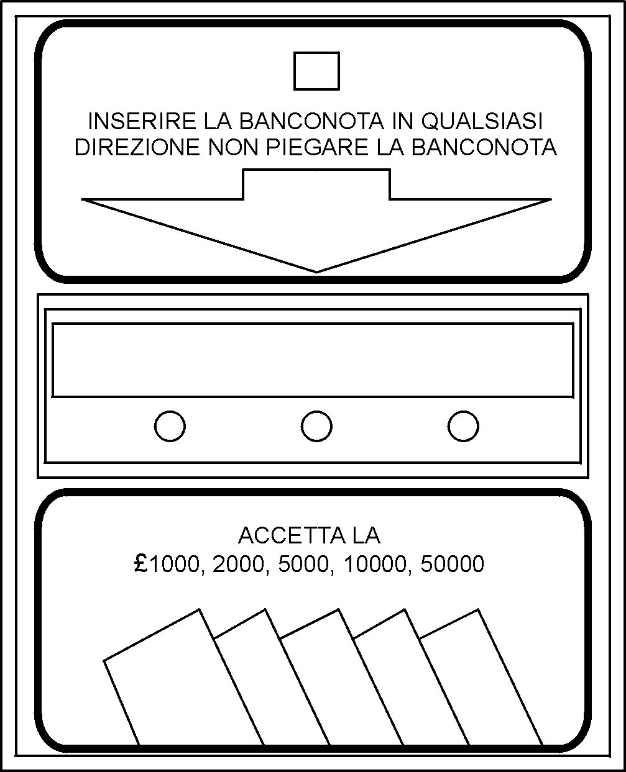
Bank note can be inserted in either direction or side. Do not bend the bank notes.
Bill acceptor functions can be set by the DIP switches which are located on the side. Functions of specific switches are shown on the following table. The currency mark is provisional:

 | FUNCTION | SW1 | SW2 | SW3 | SW4 | SW5 | SW6 | SW7 | SW8 | SW9 | SW10
* | 1 impulse / £1000 | OFF | OFF | OFF
 | 2 impulses / £1000 | OFF | OFF | ON
 | 3 impulses / £1000 | OFF | ON | OFF
 | 4 impulses / £1000 | OFF | ON | ON
 | 5 impulses / £1000 | ON | OFF | OFF
 | 10 impulses / £1000 | ON | OFF | ON
 | 20 impulses / £1000 | ON | ON | OFF
 | 100 impulses / £1000 | ON | ON | ON
 | Quick output impulse (Lo=50ms, Hi=100ms) |  |  |  | ON
* | Slow output impulse (Lo=50ms, Hi=300ms) |  |  |  | OFF
 | Inhibit low level (LOW) |  |  |  |  | ON
* | Inhibit high level (HIGH) |  |  |  |  | OFF
* | Accept £1000 |  |  |  |  |  | ON
 | Reject £1000 |  |  |  |  |  | OFF
* | Accept 2000 |  |  |  |  |  |  | ON
 | Reject £2000 |  |  |  |  |  |  | OFF
* | Accept £5000 |  |  |  |  |  |  |  | ON
 | Reject £5000 |  |  |  |  |  |  |  | OFF
* | Accept £10000 |  |  |  |  |  |  |  |  | ON
 | Reject £10000 |  |  |  |  |  |  |  |  | OFF
* | Accept £50000 |  |  |  |  |  |  |  |  |  | ON
 | Reject £50000 |  |  |  |  |  |  |  |  |  | OFF
* - manufacturer’s default settings
File: input.doc Revision: B

